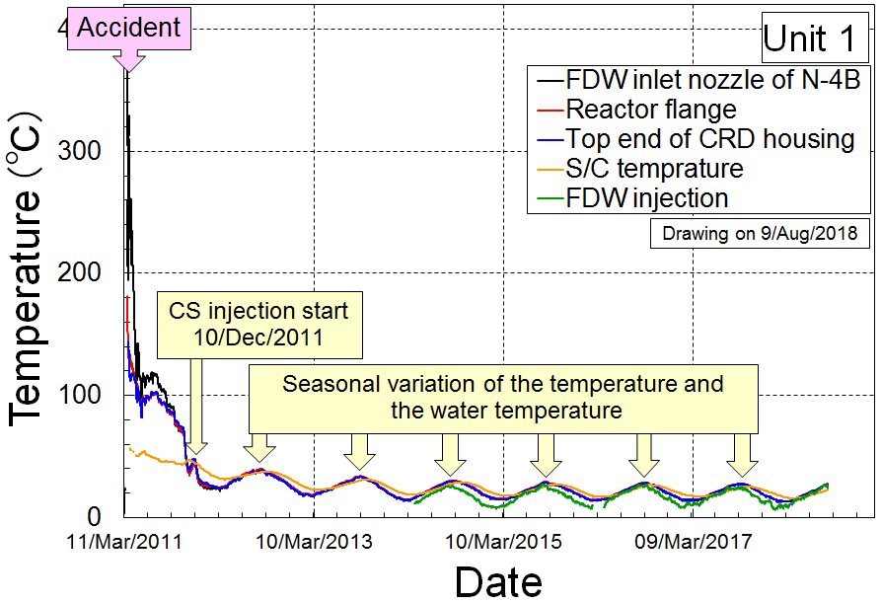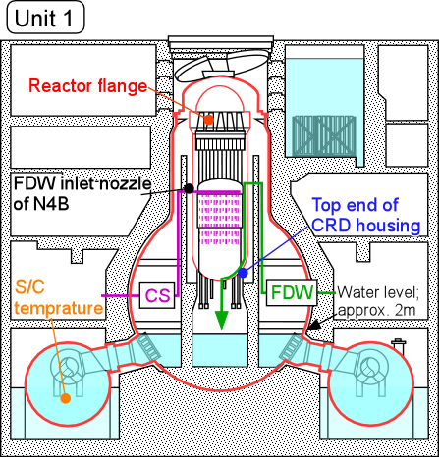
Fig. 1-1 Temperature history of the Unit 1

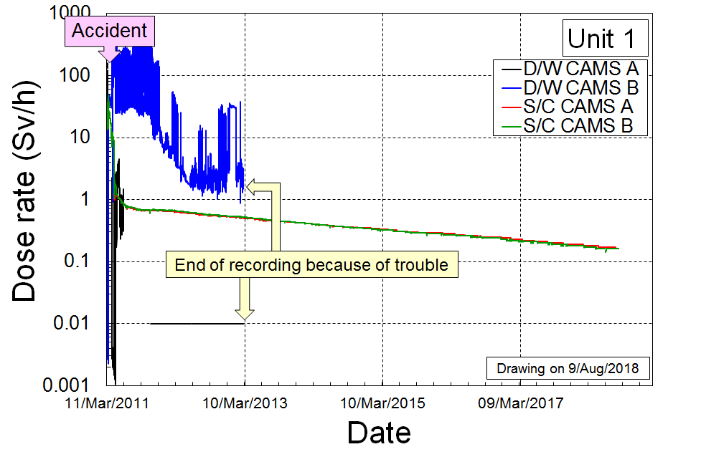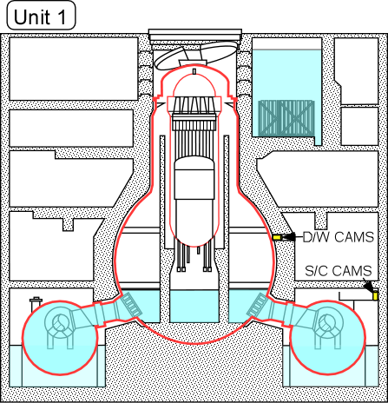
Fig. 1-2 Dose rate of the Unit 1

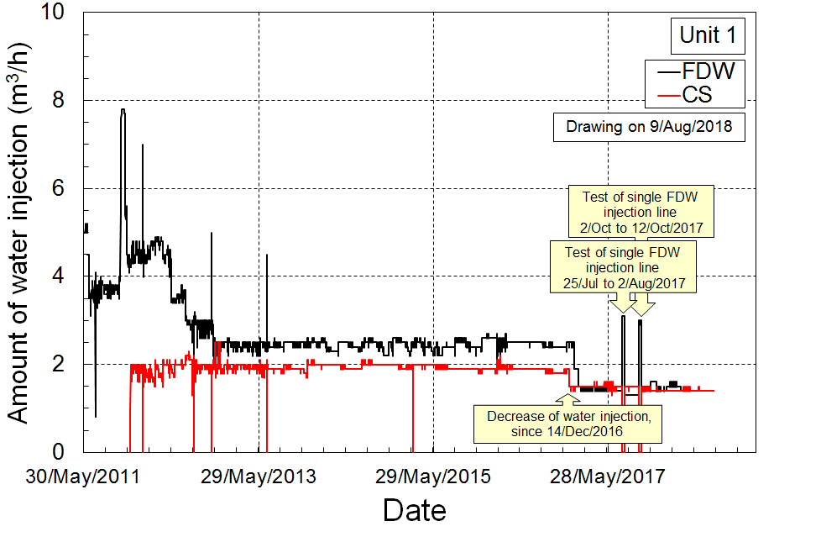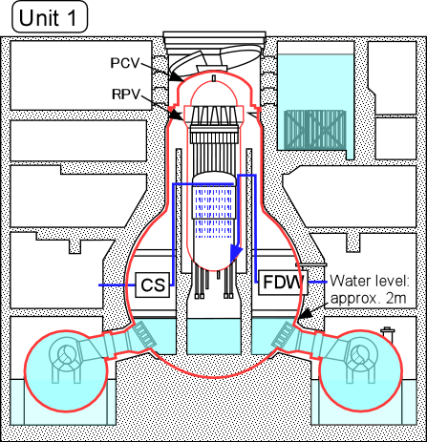
Fig. 1-3 Amount of water injection into the Unit 1

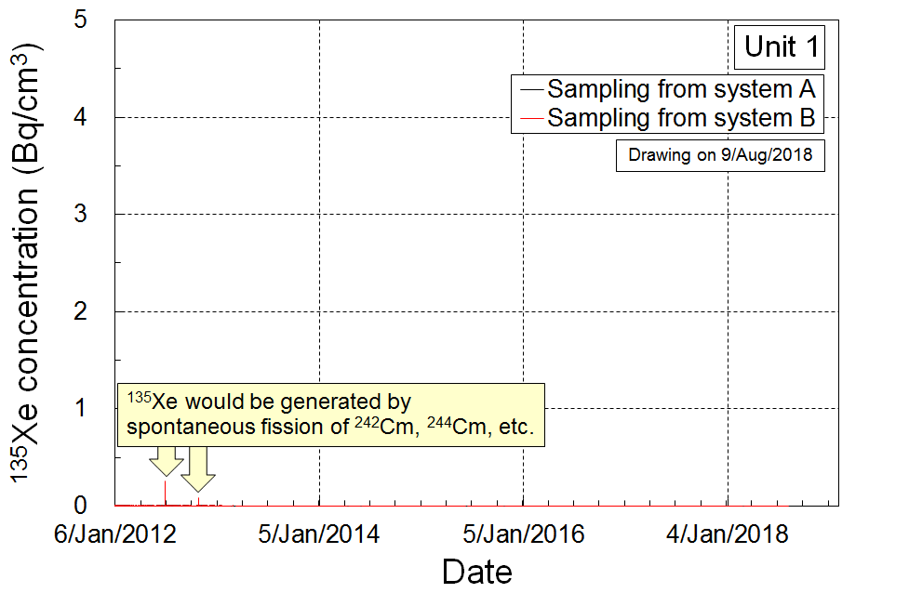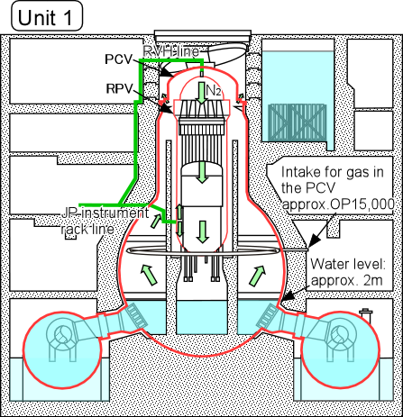
Fig. 1-4 ¹³⁵Xe concentration in the Unit 1

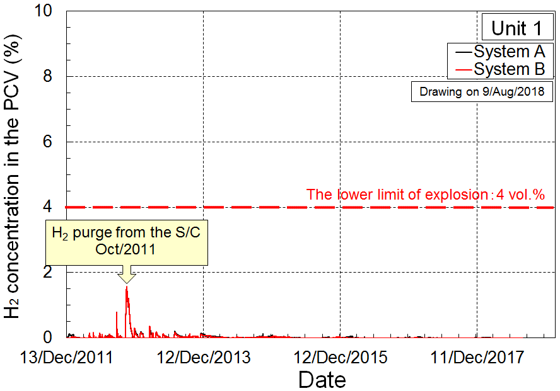
Fig. 1-5 H₂ concentration in the PCV of the Unit 1

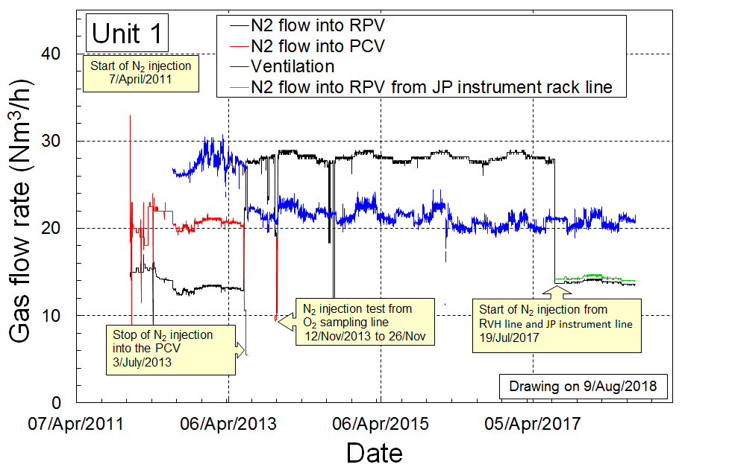
Fig. 1-6 Amount of N₂ gas injection into the Unit 1
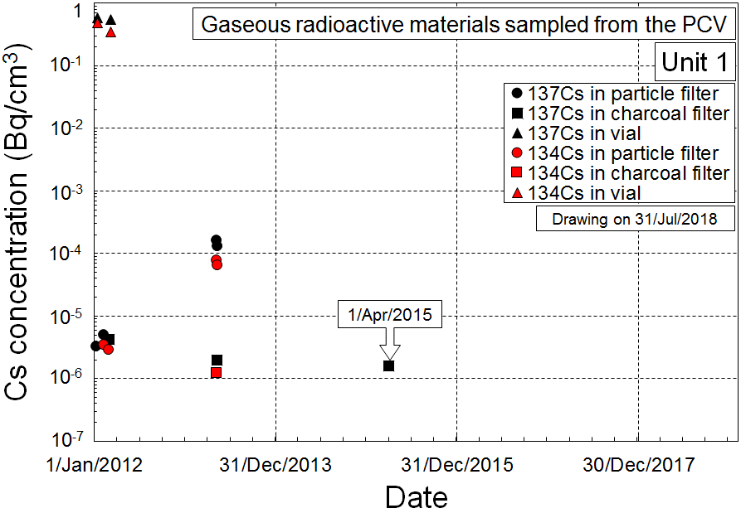
Fig. 1-7 ¹³⁷Cs and ¹³⁴Cs concentration in PCV of the Unit 1

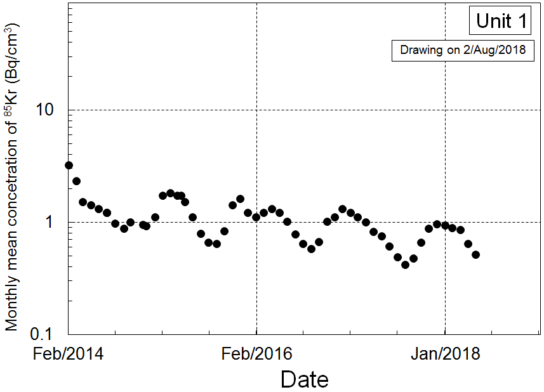
Fig. 1-8 ⁸⁵Kr concentration in PCV of the Unit 1

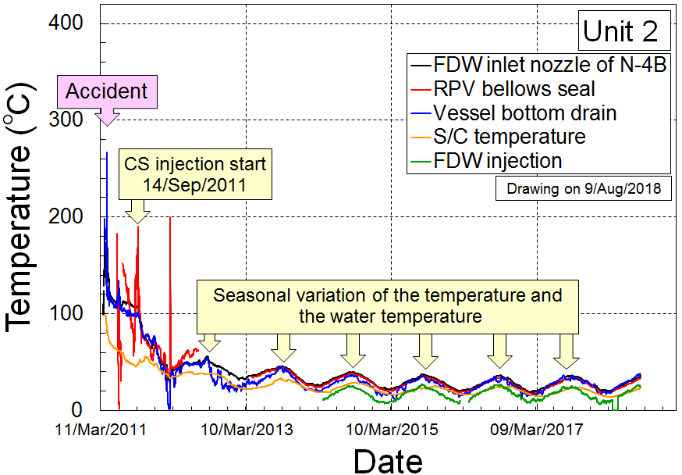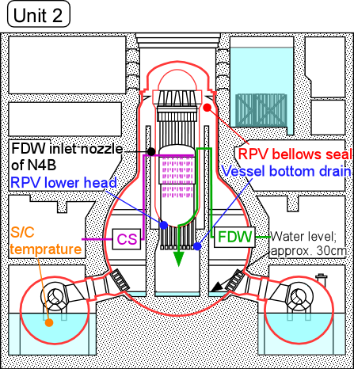
Fig. 2-1 Temperature history of the Unit 2

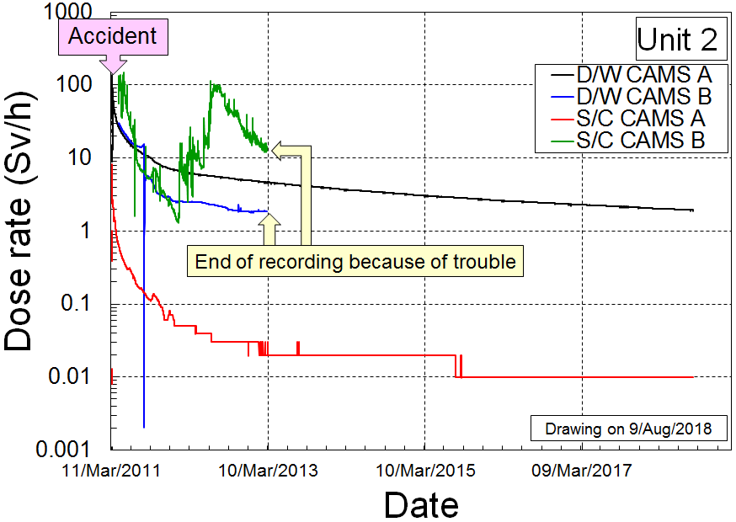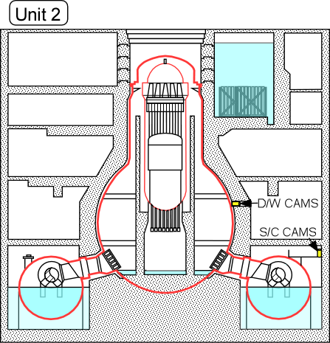
Fig. 2-2 Dose rate of the Unit 2

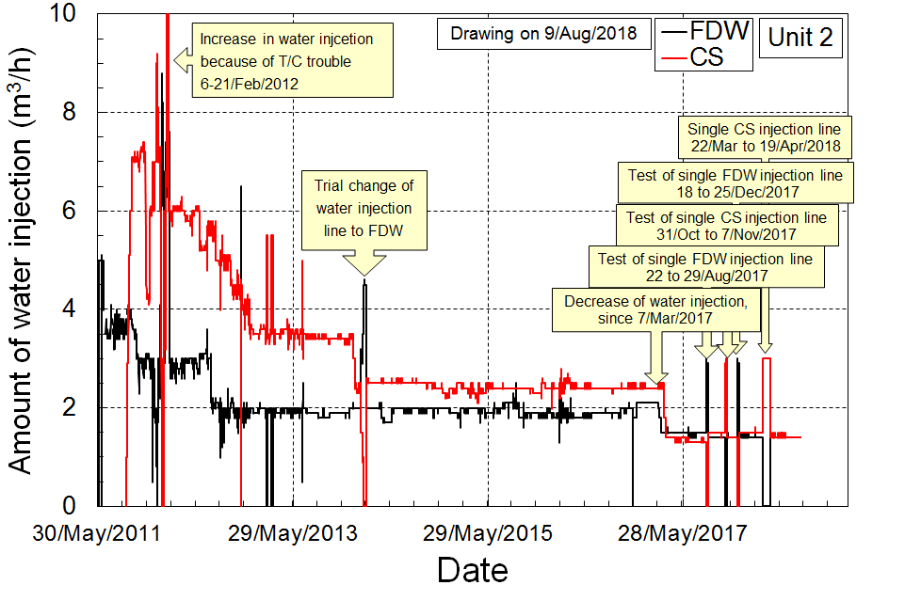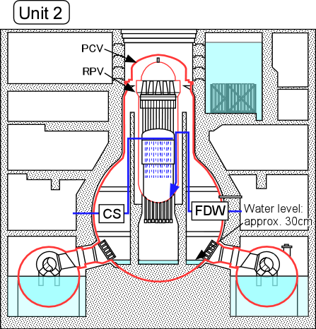
Fig. 2-3 Amount of water injection into the Unit 2

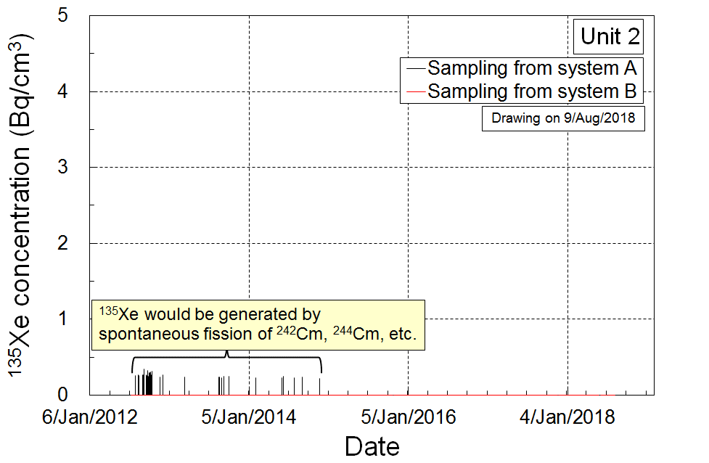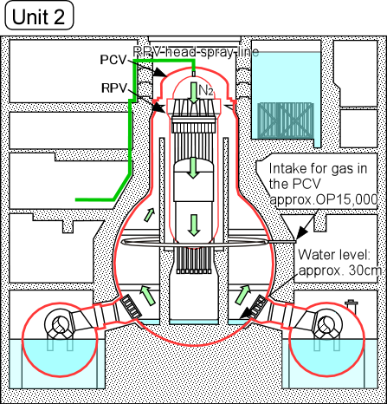
Fig. 2-4 ¹³⁵Xe concentration in the Unit 2

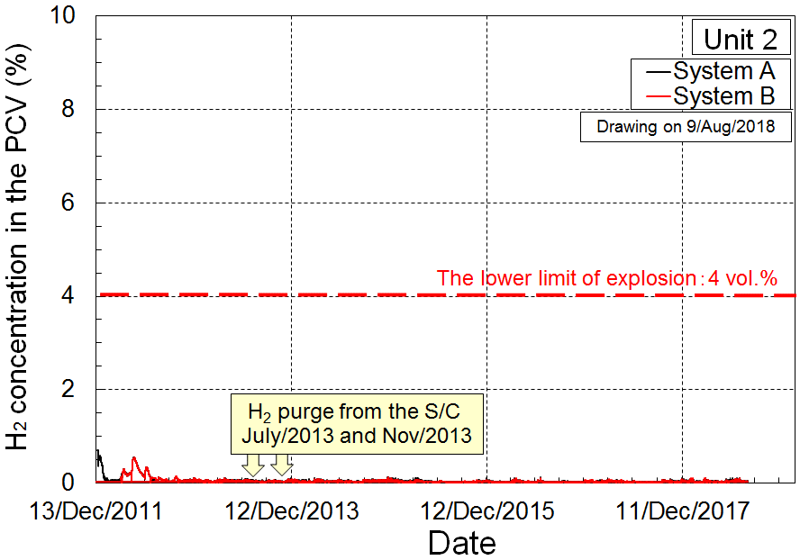
Fig. 2-5 H₂ concentration in the PCV of the Unit 2

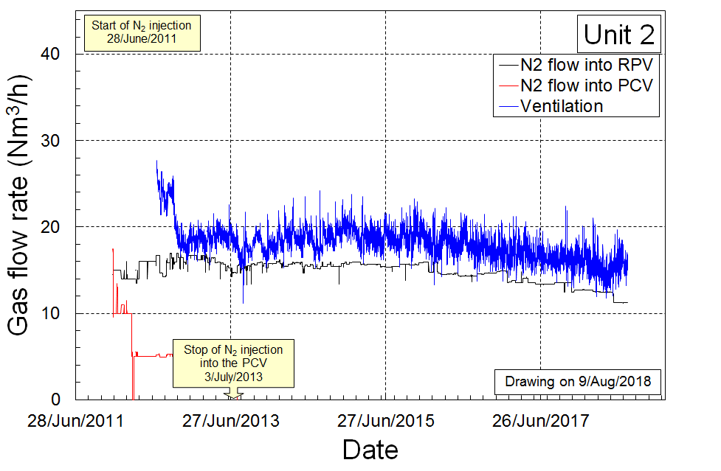
Fig. 2-6 Amount of N₂ gas injection into the Unit 2

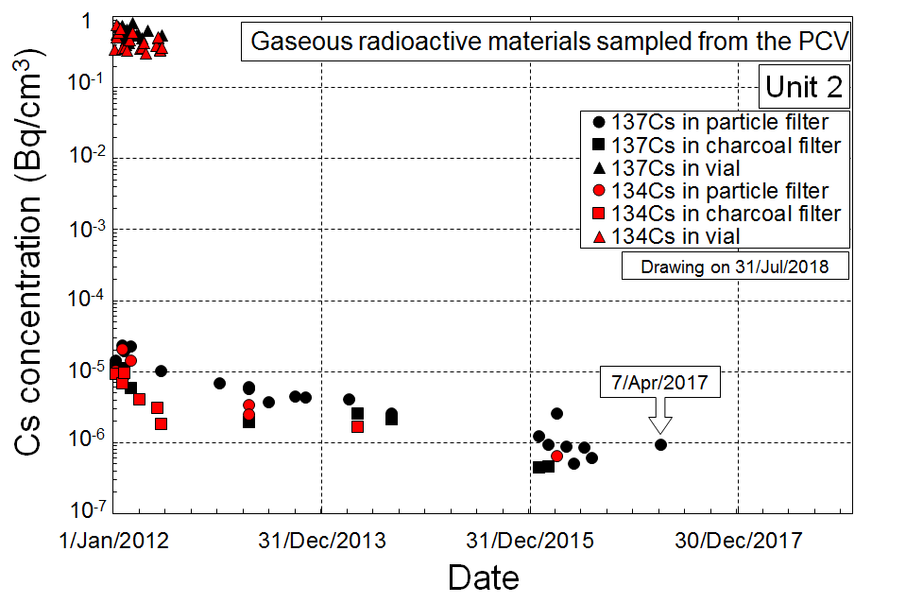
Fig. 2-7 ¹³⁷Cs and ¹³⁴Cs concentration in the PCV of the Unit 2

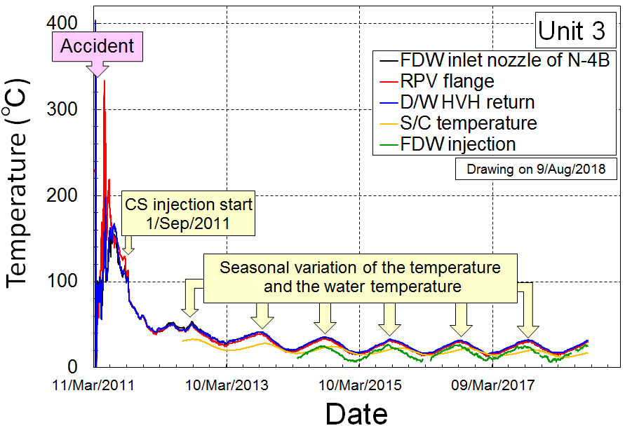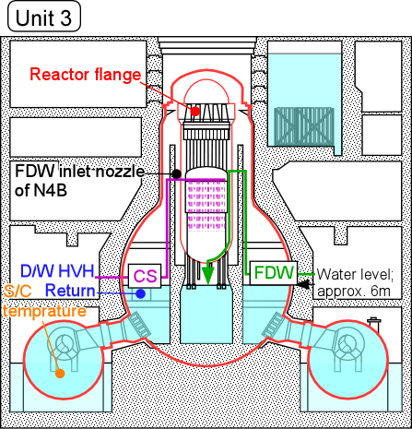
Fig. 3-1 Temperature history of the Unit 3

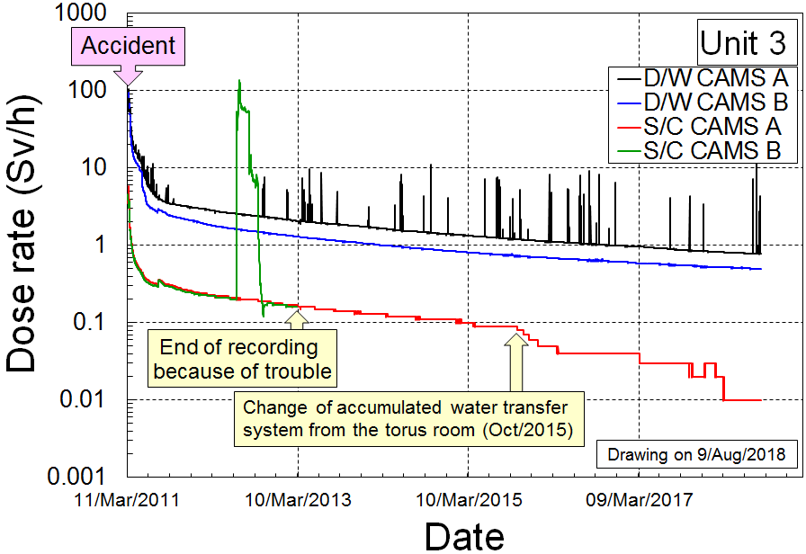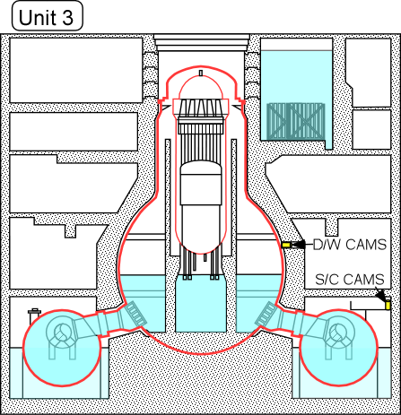
Fig. 3-2 Dose rate of the Unit 3

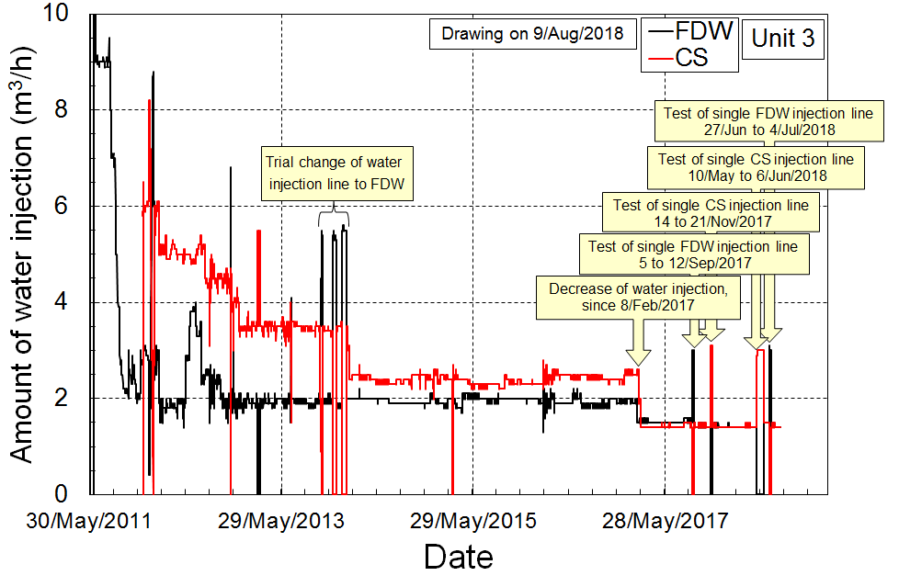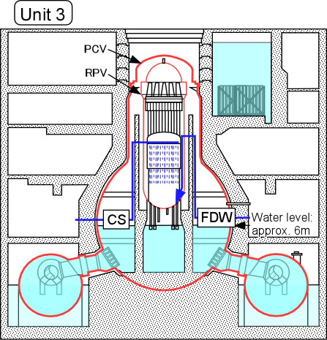
Fig. 3-3 Amount of water injection into the Unit 3

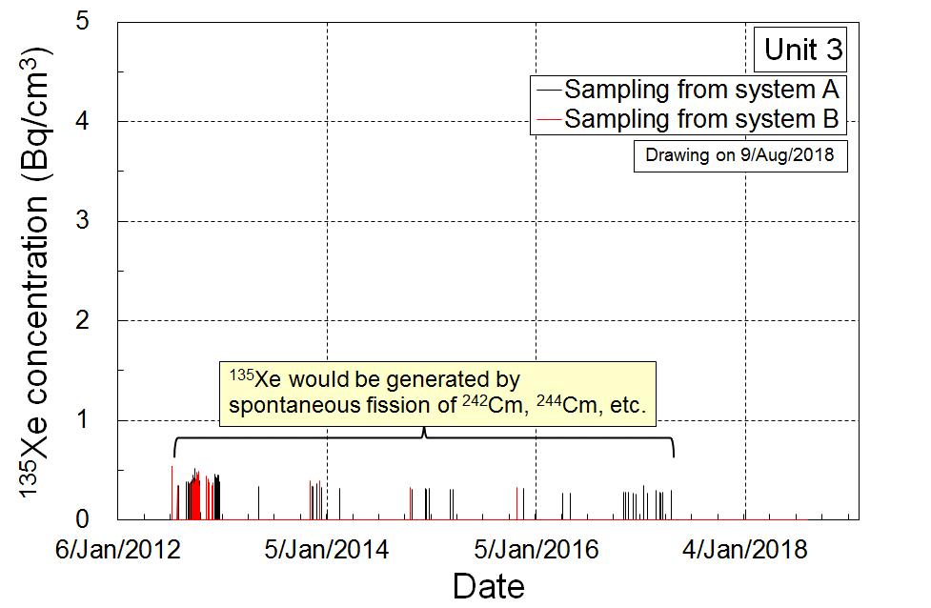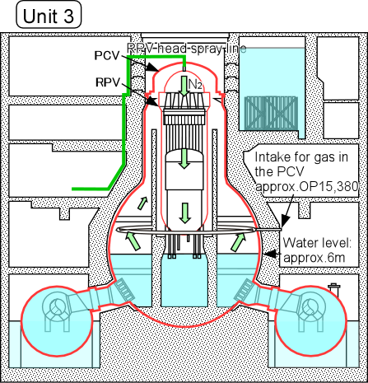
Fig. 3-4 ¹³⁵Xe concentration in the Unit 3

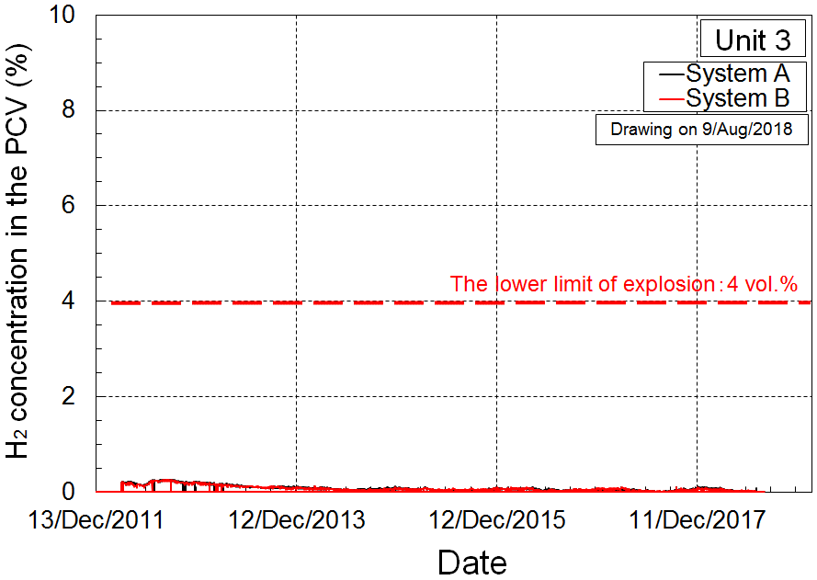
Fig. 3-5 H₂ concentration in the PCV of the Unit 3

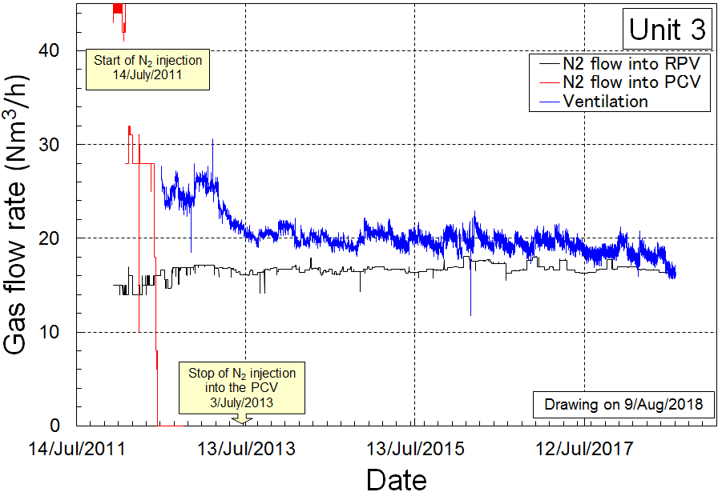
Fig. 3-6 Amount of N₂ gas injection into the Unit 3

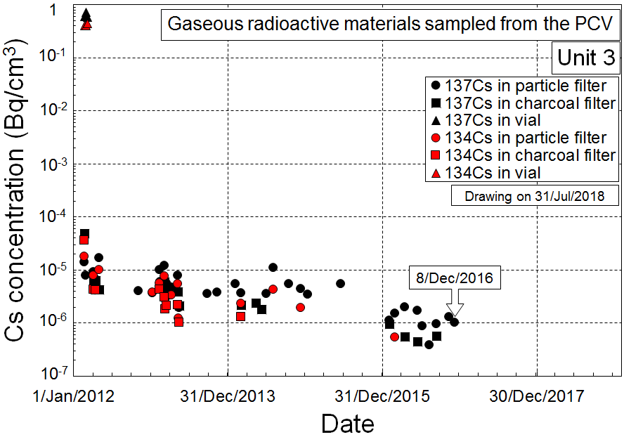
Fig. 3-7 ¹³⁷Cs and ¹³⁴Cs concentration in PCV of the Unit 3

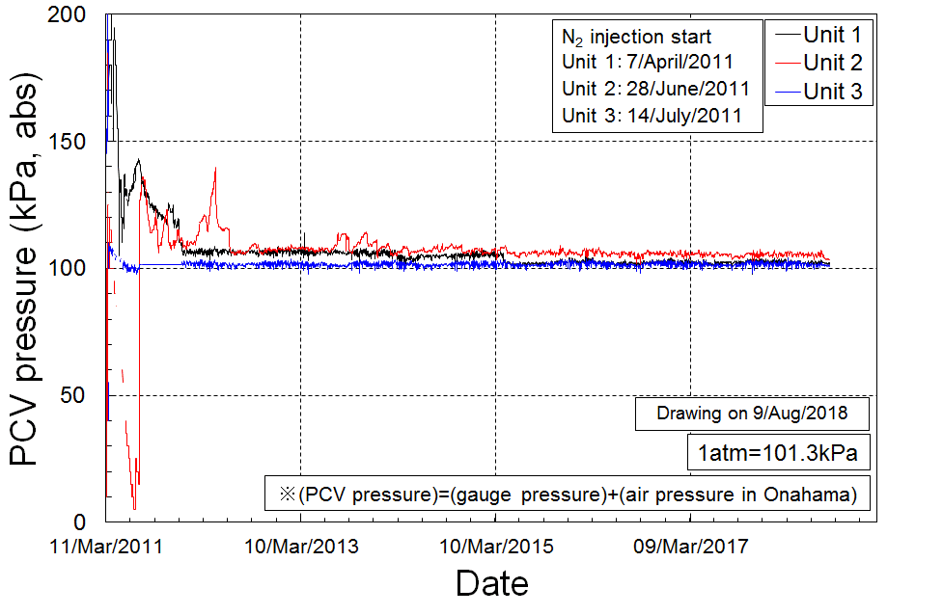
Fig. 4-1 PCV pressure

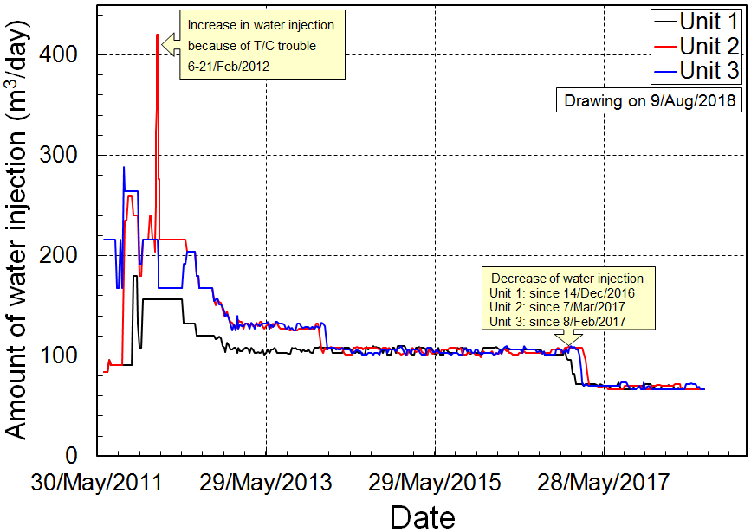
Fig. 4-2 Amount of water injection
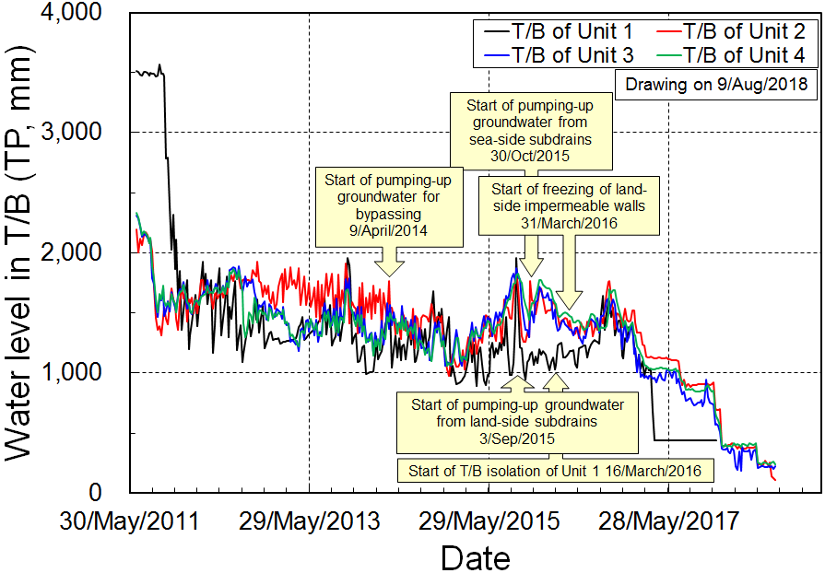
Fig. 4-3 Water level in T/B

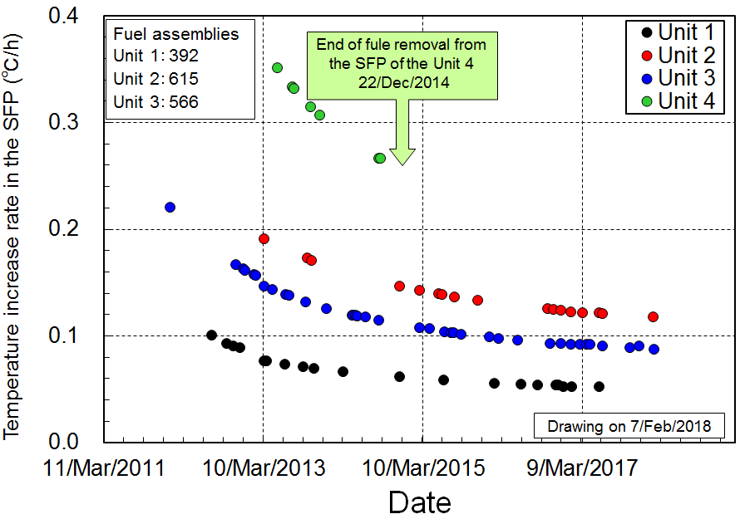
Fig. 4-4 Temperature increase rate in spent fuel pool

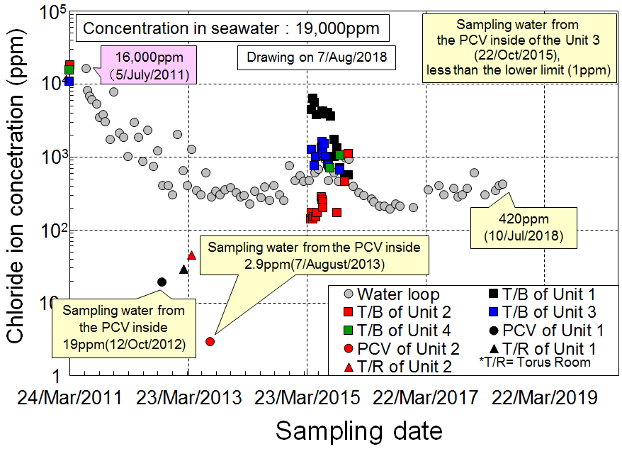
Fig. 4-5 Cl⁻ concentration in accumulated water in PCVs and turbine building

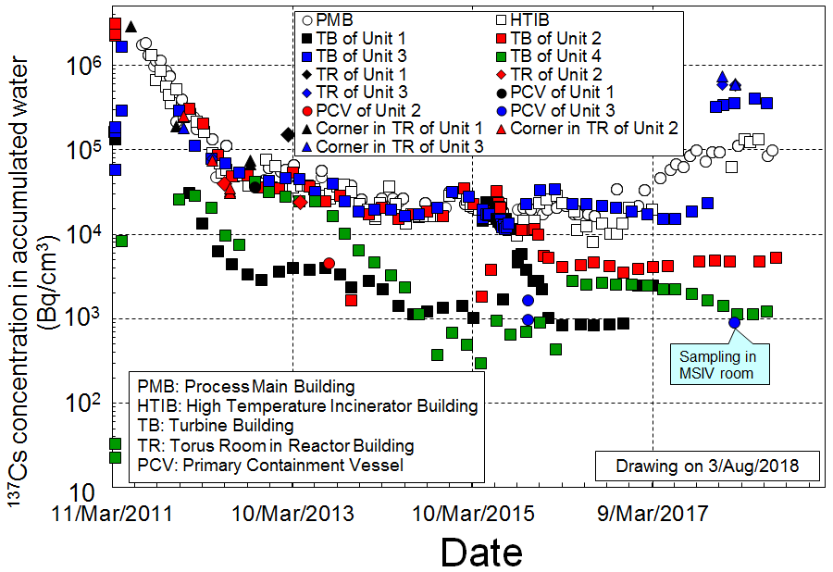
Fig. 4-6 ¹³⁷Cs concentration in accumulated water in PCVs, torus rooms, turbine buildings, process main building and high temperature incinerator building

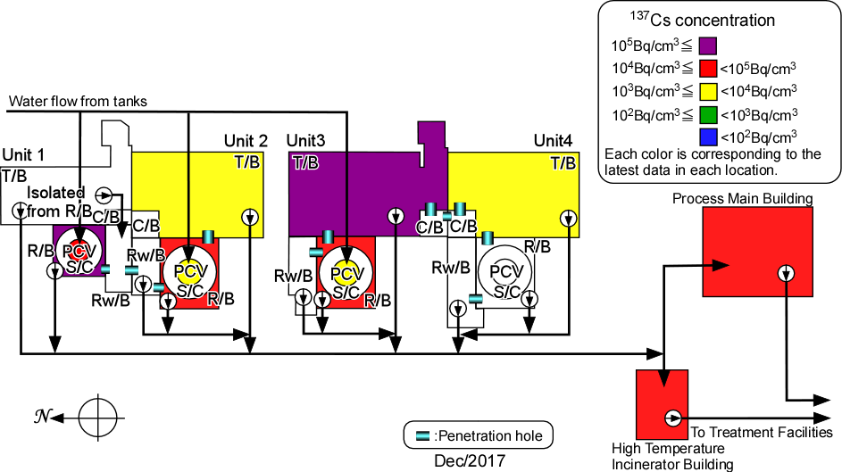
Fig. 4-7 ¹³⁷Cs concentration in accumulated water of each building

